EXPERIENCING AN IN-FLIGHT FOOD COMA WITH THESE THREE AIRLINES
Three airlines with the best business class food in the world
Unlike flying economy class, you have expectations on service, food, seats and amenities when you book business class. If you ever fly the following three airlines’ business class, you taste buds will be spoiled. Keep reading and you may want to hop on one of their flights right away relishing the deliciousness.

All Nippon Airlines
All Nippon Airlines won the world’s best business class on-boarding catering, according to the consumer aviation website Skytrax. Indulge yourself with a menu including traditional Japanese Kaiseki cuisine and international cuisines presented to you by The Connoisseur, a team of eighteen world-renowned chefs. ANA’s international cuisines are exquisite but its Kaiseki meal is truly exceptional. The appetizers look so delicate as they are carefully arranged on painted porcelain wares. You get to relish on snow crab, clam, scallop and sea urchin. They taste as amazing as their presentation.
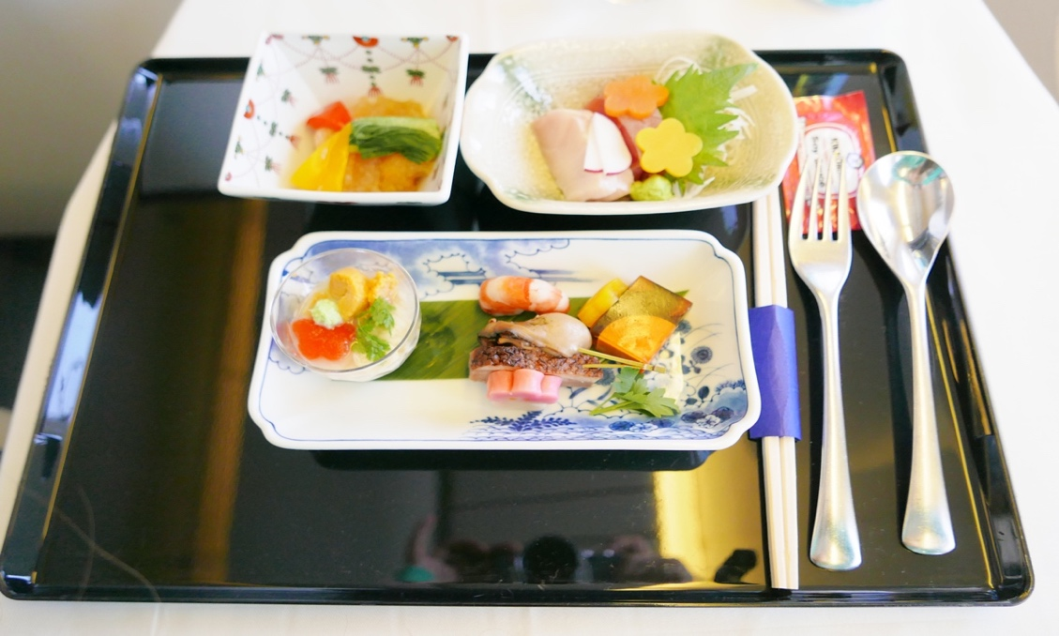
The main course varies from flight to flight. If you fly inbound to Tokyo, you will likely be served a simmered trout seasoned in soy sauce to perfection with steamed rice, Japanese pickles and miso soup.
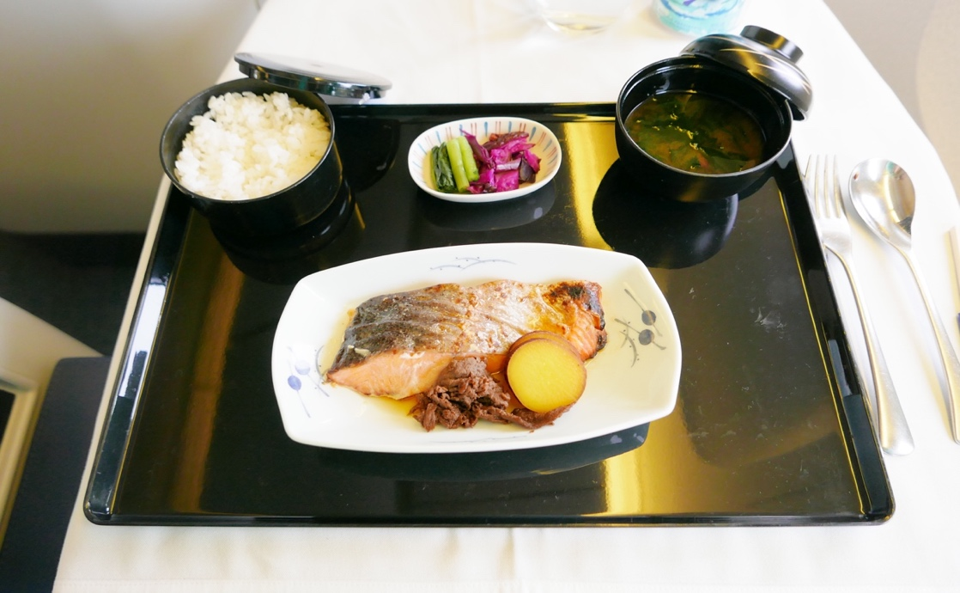
If the meal does not satisfy you or you simply want to snack on something while enjoying the inflight entertainment, ANA got you covered as it offers Light Dishes Anytime such as pasta, sandwich, cheese plate and even ramen from the most famous Japanese ramen shop Ippudo.

Turkish Airlines
Turkish Airlines’ food menu is updated every season. Many passengers choose to fly with its business class more than once for the food on board never disappoints them. “I’ve flown Turkish Airlines’ business class for more than 20 times now and their food always satisfy my appetite,” says flight guru Sam Chui in his review on YouTube. Turkish Airlines knows how to add a little fun to the boring flight time. From the point you step onto the aircraft, a white-hat chef greets you by the door, making you feel like walking into a fine dining restaurant. A few moments later, he/she comes to take your food order and brings you an array of welcome drinks.
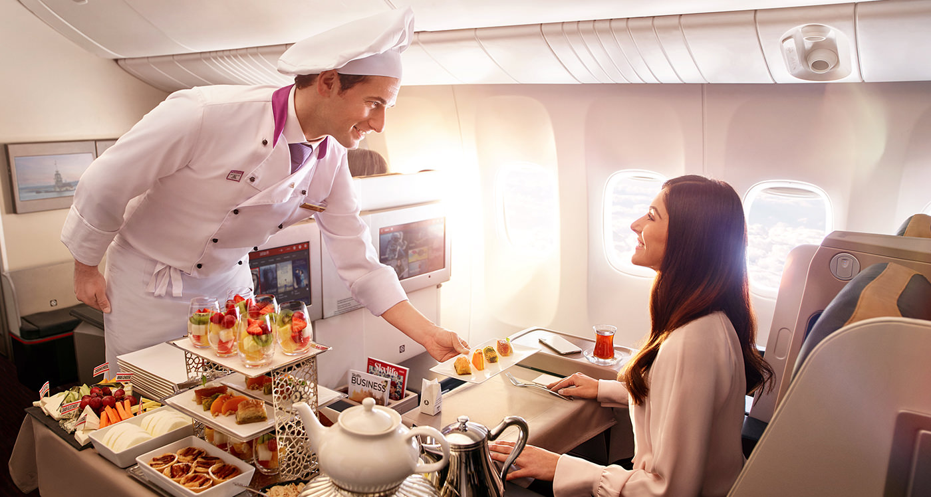
All dishes on board are prepared and served to you by these flying chefs. Turkish Airline offers signature dishes like kebab lamb skewer, stuffed eggplants, Pide (Turkish pizza) and so on.
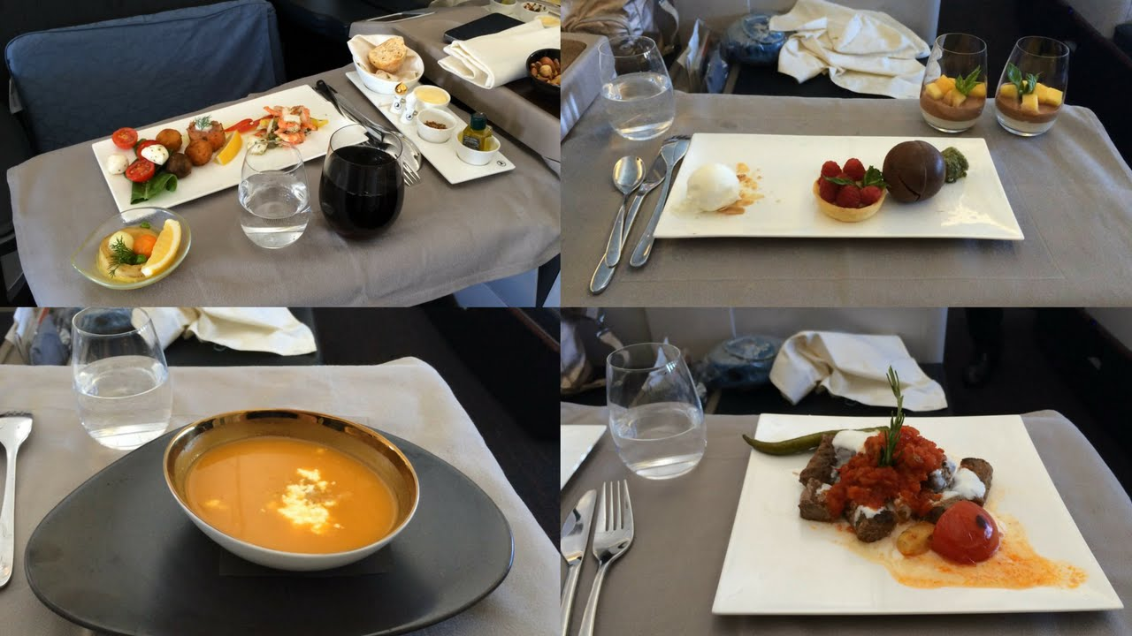
If you are new to Mediterranean food, these beautifully presented dishes will give you a great introduction to Turkish cuisine. Finish off you meal with a piece of Turkish Delight and get ready for some good rest before landing.

Singapore Airlines
The national airline of Singapore is ranked second on the best airline in the world in 2019, according to Business Insider. Similar to ANA, Singapore Airlines’ onboard menu is created by chefs around the world. Singapore Airlines brings the best dishes of its national cuisine to you up in the air. Satay skewers, steamed lobster dumplings, Hainan chicken rice and you name it.
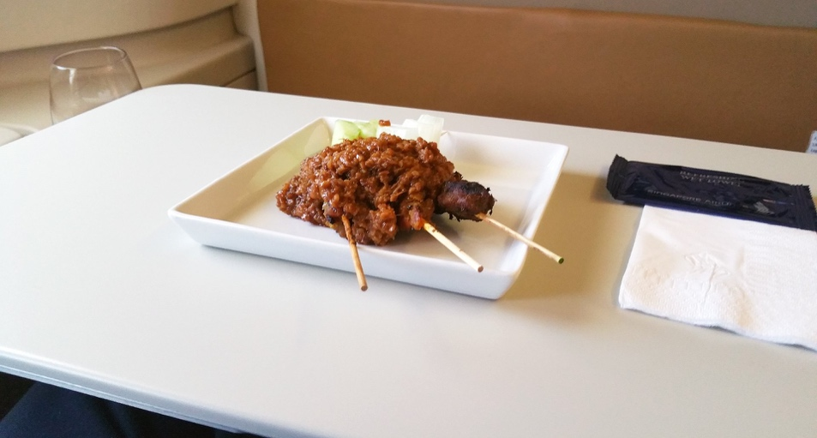
Hainan chicken rice is the airlines’ signature main course. It comes with herbal boiled chicken, steamed Chinese broccoli, jasmine rice in grated ginger, and three types of dipping sauces: chili sauce, grated ginger and chopped scallion in veggie oil, and Hoisin sauce. The chicken is so tender that it melts in your mouth and the sauce brings the flavor out to spur your taste buds.
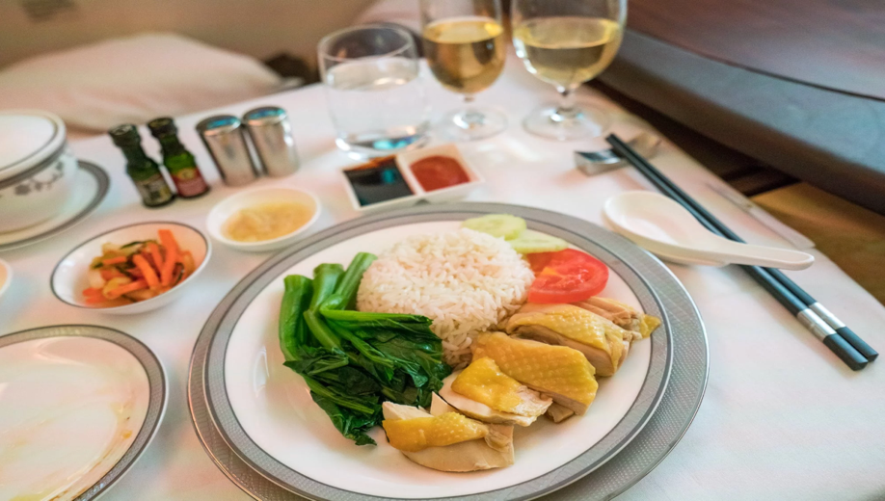
Singapore Airlines offers the Book the Cook option which allows you to choose from a wide variety of main courses 24 hours before departure. Your fine dining experience has just been taken to a new level with your preference secured in advance.
Fly to your next destination with one of the three airlines and enjoy your business class food experience to the fullest.
# # #
For more information, contact Rosemary Xu, ziqianx@usc.edu, 818-964-4867

